GROUNDWORK BY JALLA · 21 AUGUST 2026

Every automated email the product sends
Requested at the 20 August meeting, for a quality review of what customers actually receive. The minutes record two automated emails — one for signups, one for contractor invitations. The real number is twelve, plus three more that were built and are now unreachable. Of the eight whose wording is ours to review, exactly one is reaching its recipient.
Eight have templates in our codebase and are reproduced in full below, in both languages, exactly as sent. The other four are Supabase's own and must be reviewed in the Supabase dashboard; they are listed at the end with the place to find each one.

Only one of these eight is actually arriving
Two separate faults, both completely silent. Neither shows an error to the customer, and neither writes anything to a log a person would read — which is why they have gone unnoticed. Between them they account for six of the eight emails below.
The four contractor-facing emails — the application copy, the team alert, and both decisions — fail because of how our hosting loads code. It is a rule the codebase already documents, and it was applied everywhere except these files. The applicant still sees “submitted” on screen; nothing else happens.
The two homeowner emails fail for an unrelated reason: a database change in an earlier migration stopped recording customer email addresses. The code looks for an address, finds none, and returns without sending or complaining. Anyone who signed up after that change has never received either one.
Both faults are fixed in the same change as this audit, along with an open relay on the invite endpoint that let anyone send mail from our domain. The statuses below describe the product as it stands today, before that fix is deployed — so this document doubles as the before-picture.
6  Not arriving | 1  Sending | 1  Dead code | 5  Reviewed elsewhere

To contractors
Everyone applying to, or working through, the Founding Network. · 4 emails

Application received — NOT ARRIVING
When | Sent the moment someone submits the Founding Network application form.
Goes to | The applicant
Status | Never arrives. The handler dies before it can send — see the finding above.
In the code | api/contractor-application-notify.ts

English — We received your Founding Network application
Part 1 of 4
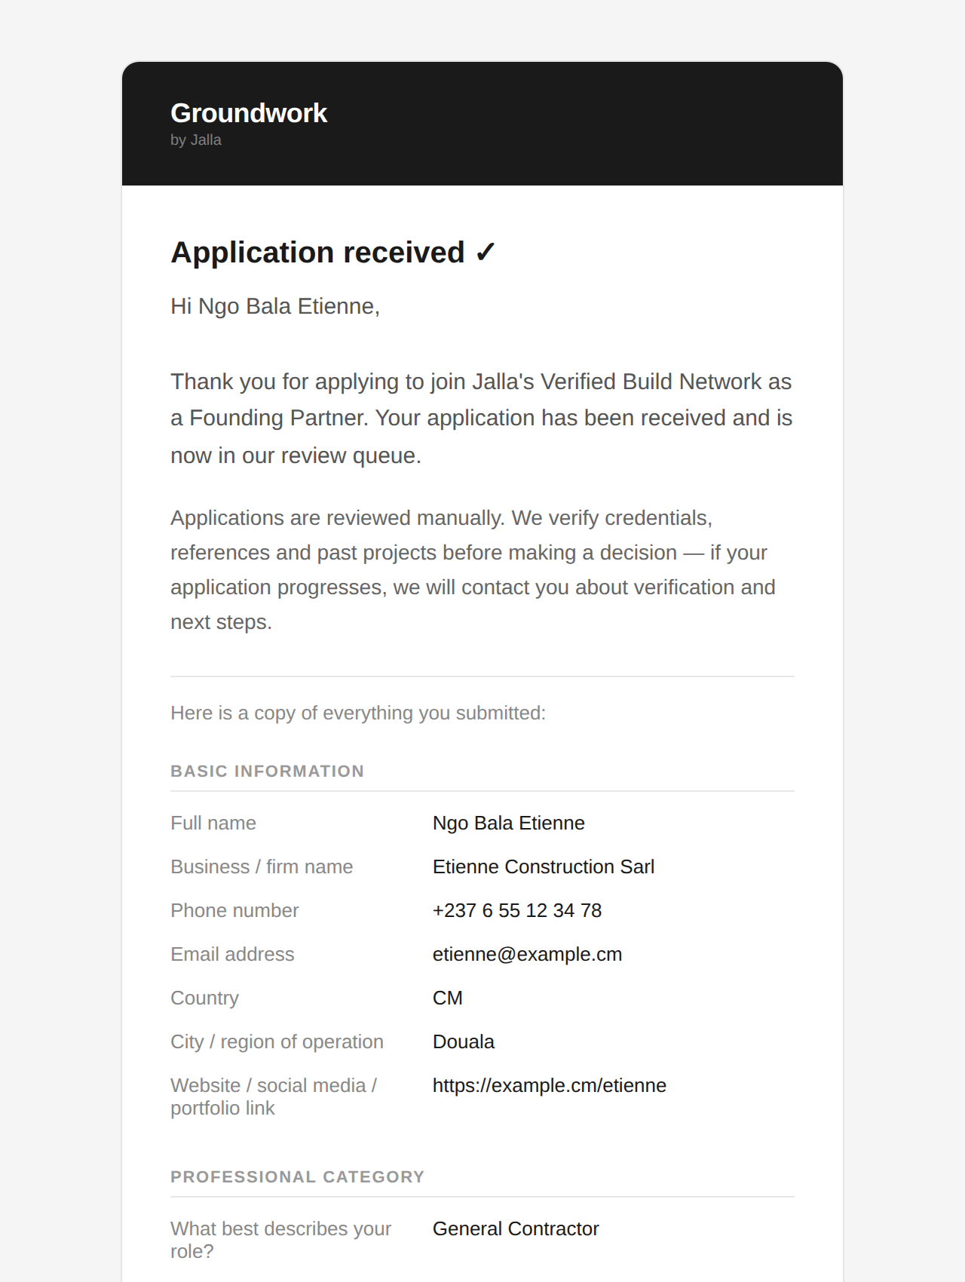
Part 2 of 4
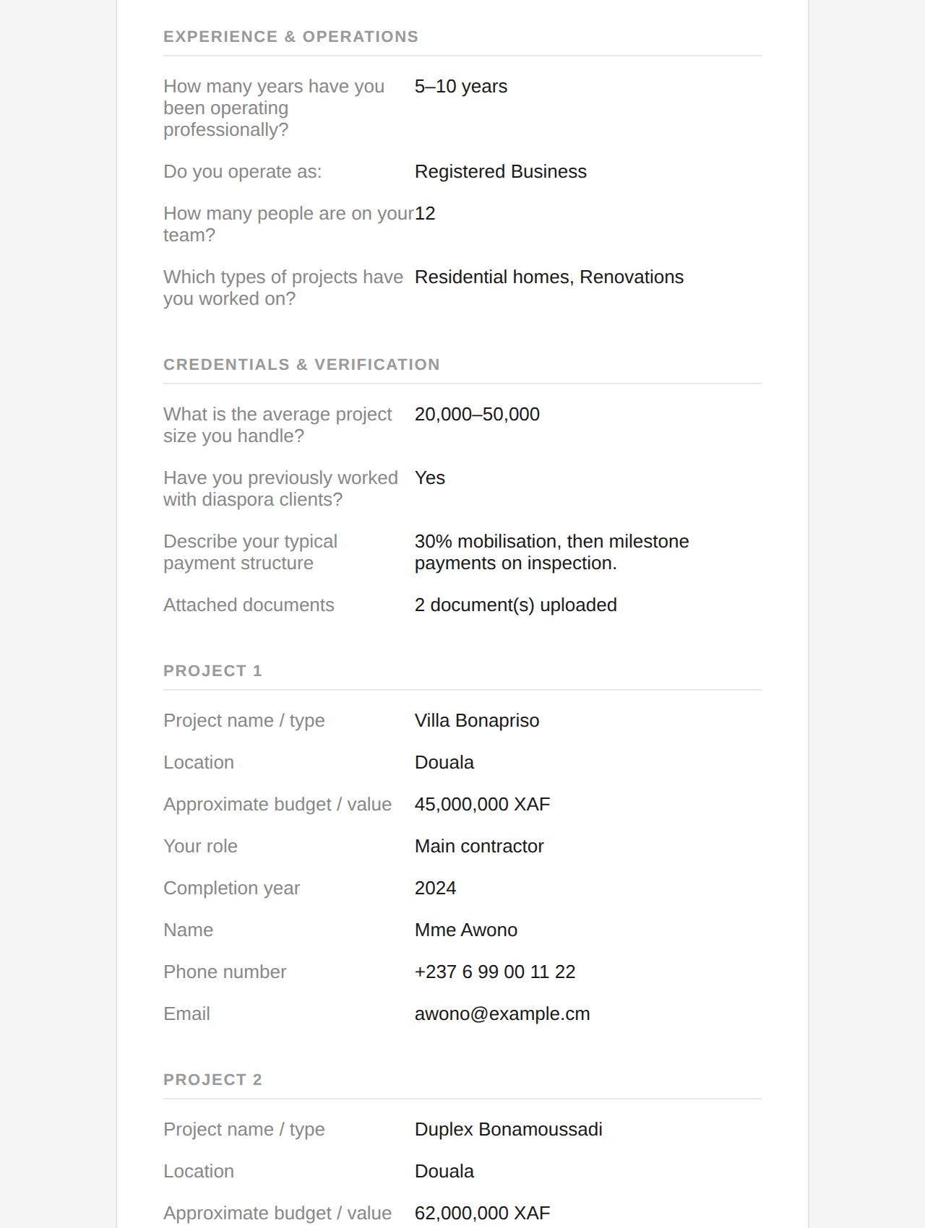
Part 3 of 4
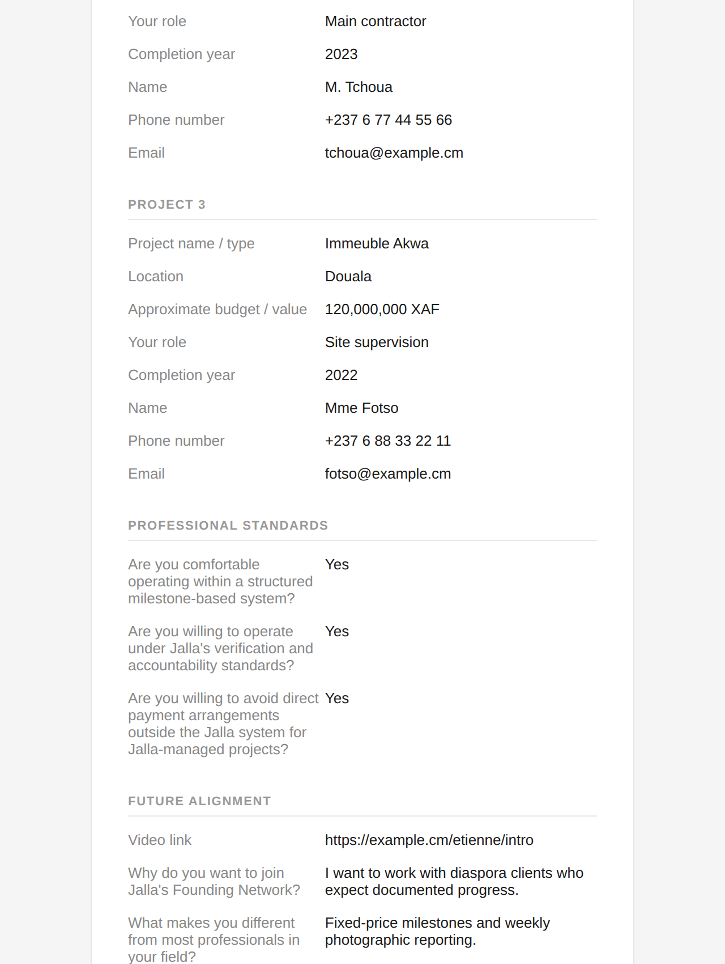
Part 4 of 4
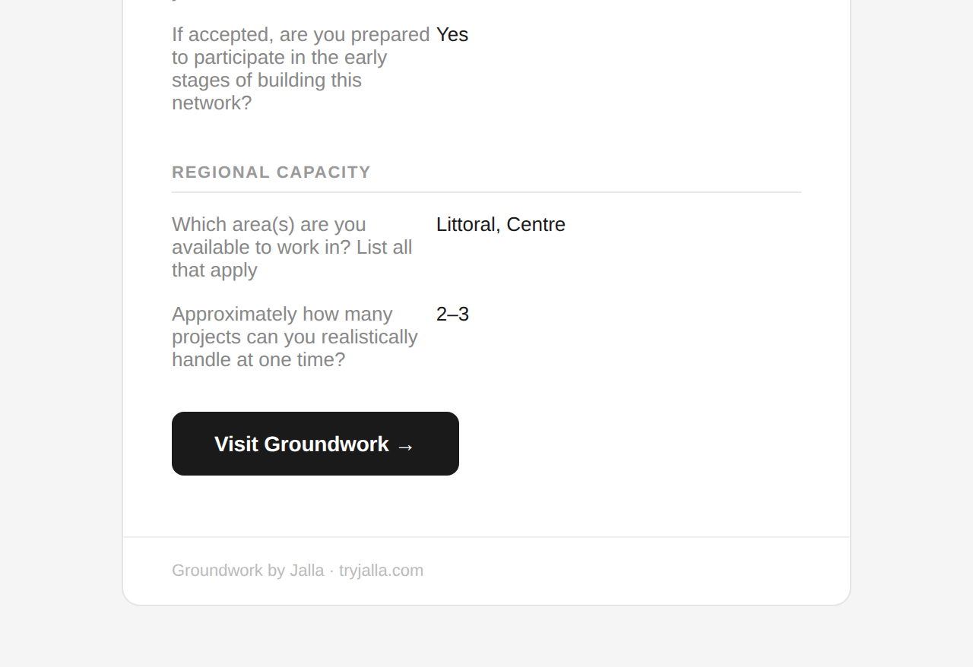

Français — Nous avons bien reçu votre candidature au Réseau Fondateur
Part 1 of 4
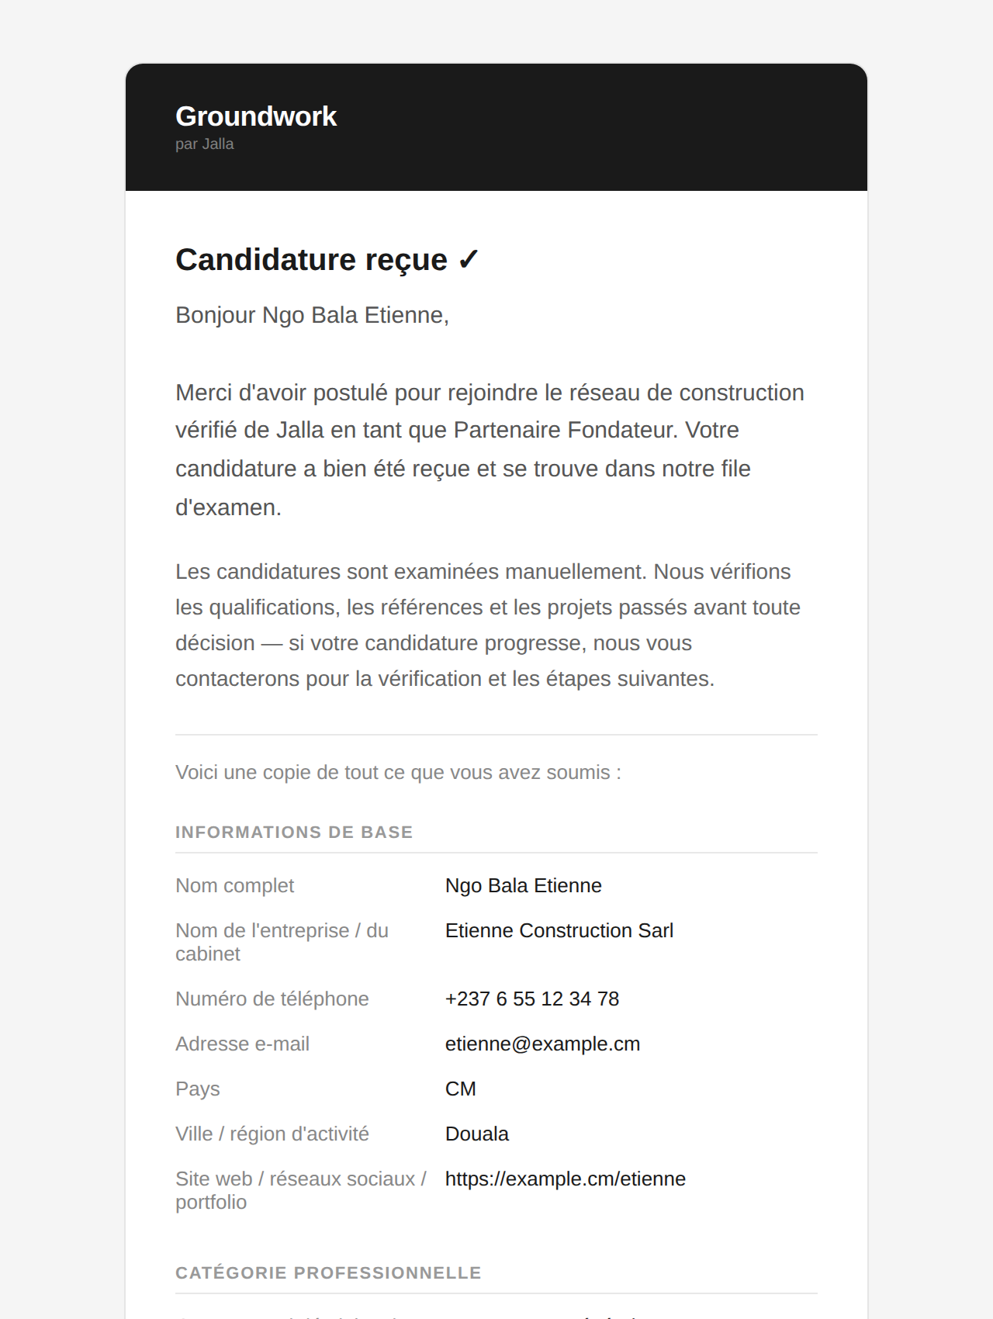
Part 2 of 4
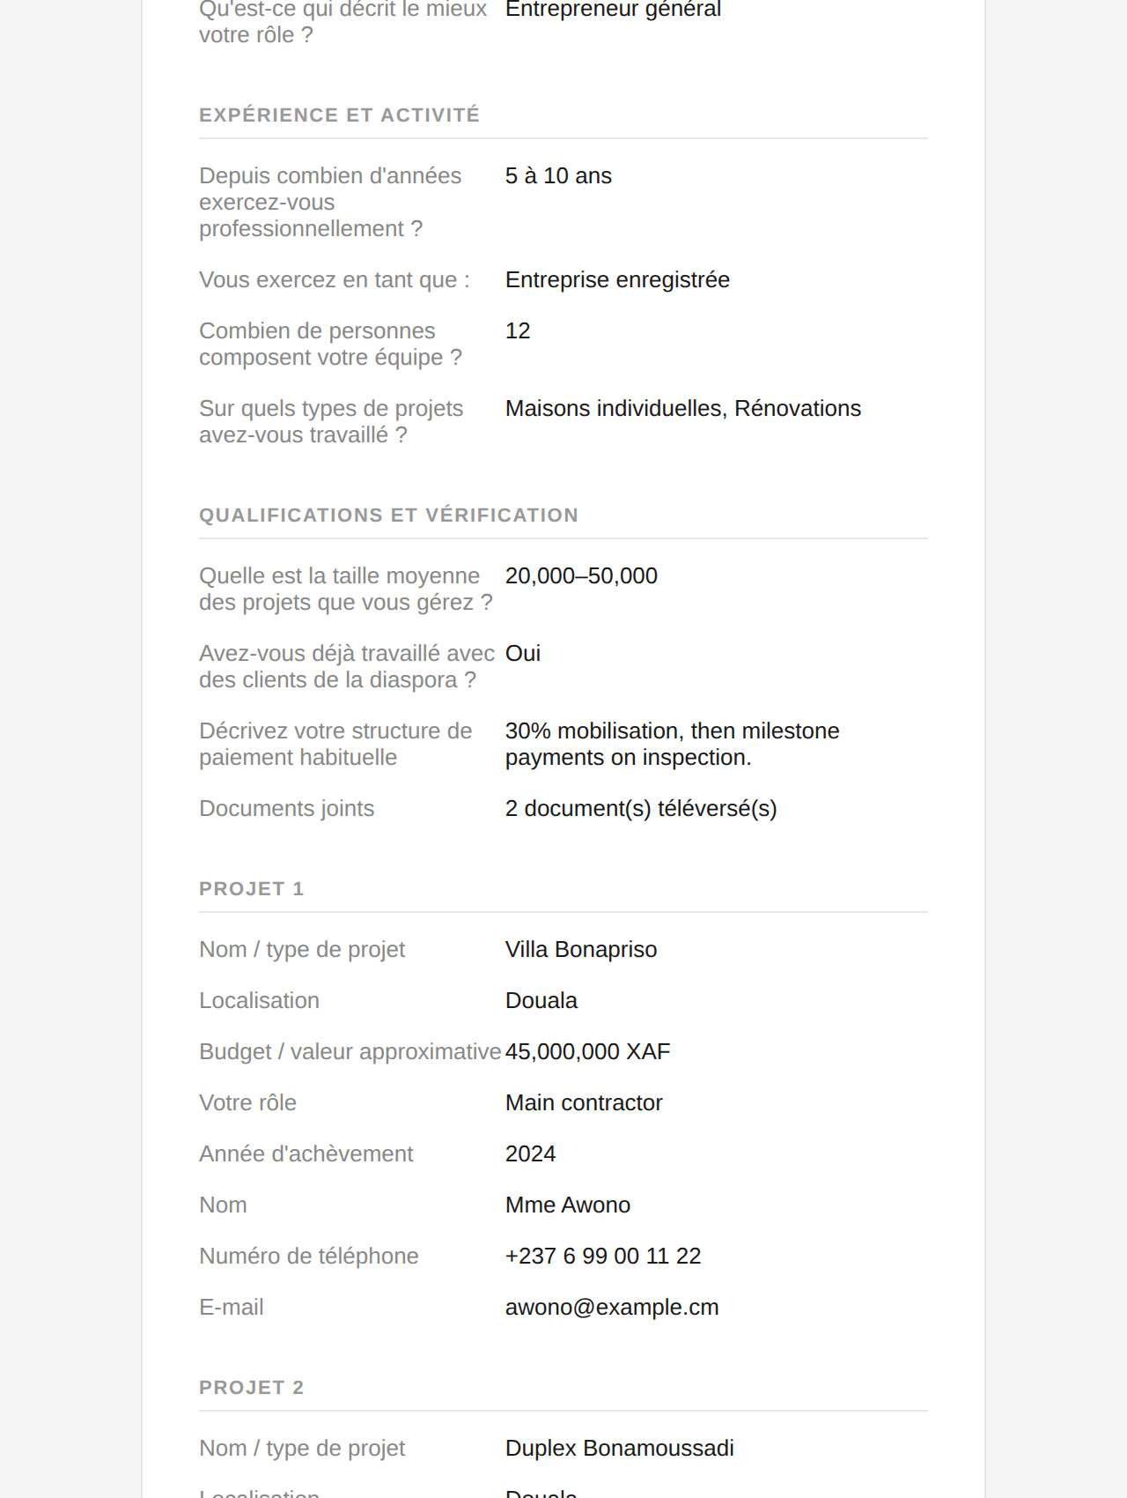
Part 3 of 4
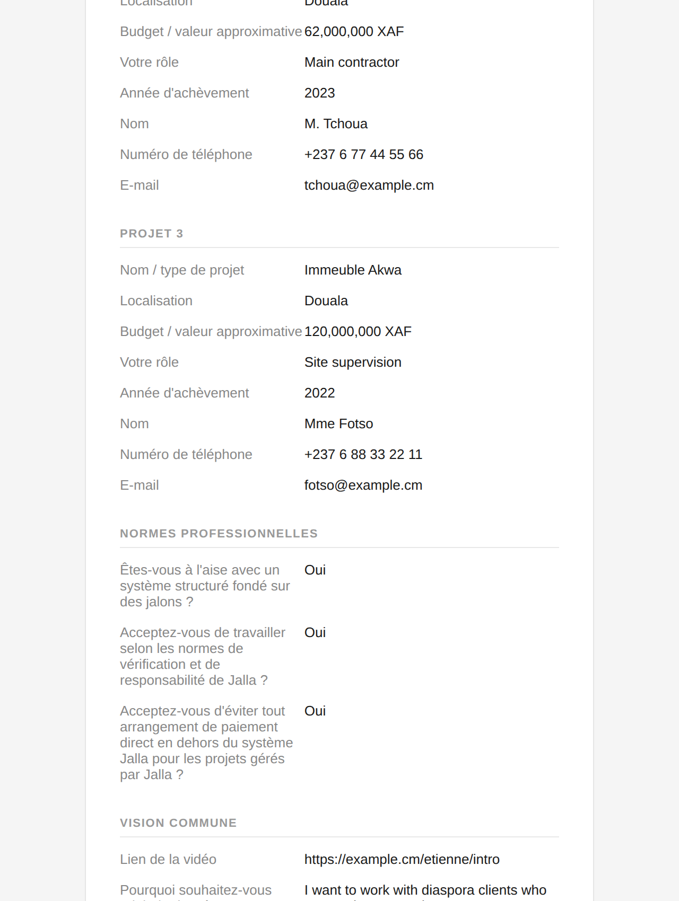
Part 4 of 4
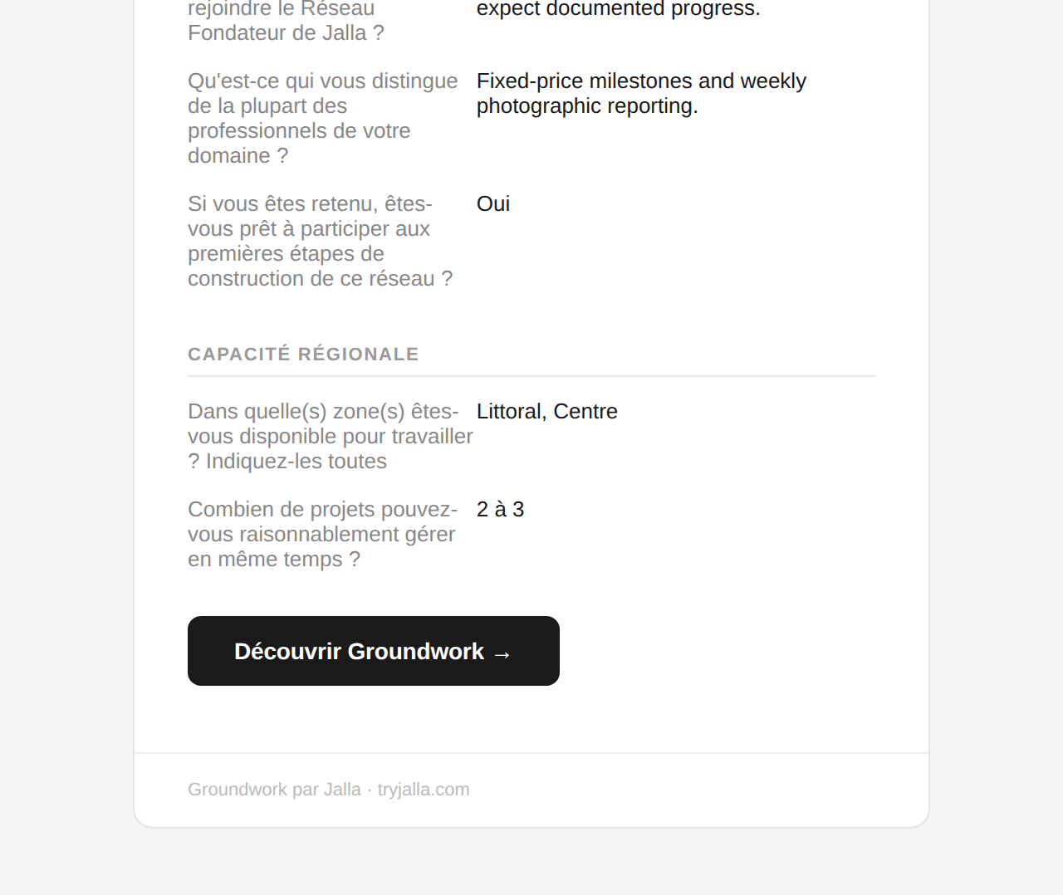

Accepted — NOT ARRIVING
When | Sent when an admin presses Accept on an application in the admin console.
Goes to | The applicant
Status | Never arrives, same cause. The admin does see a “could not notify” warning, so this is the one failure the team may already have noticed.
In the code | api/send-application-decision.ts

English — You have been accepted into the Groundwork Founding Network
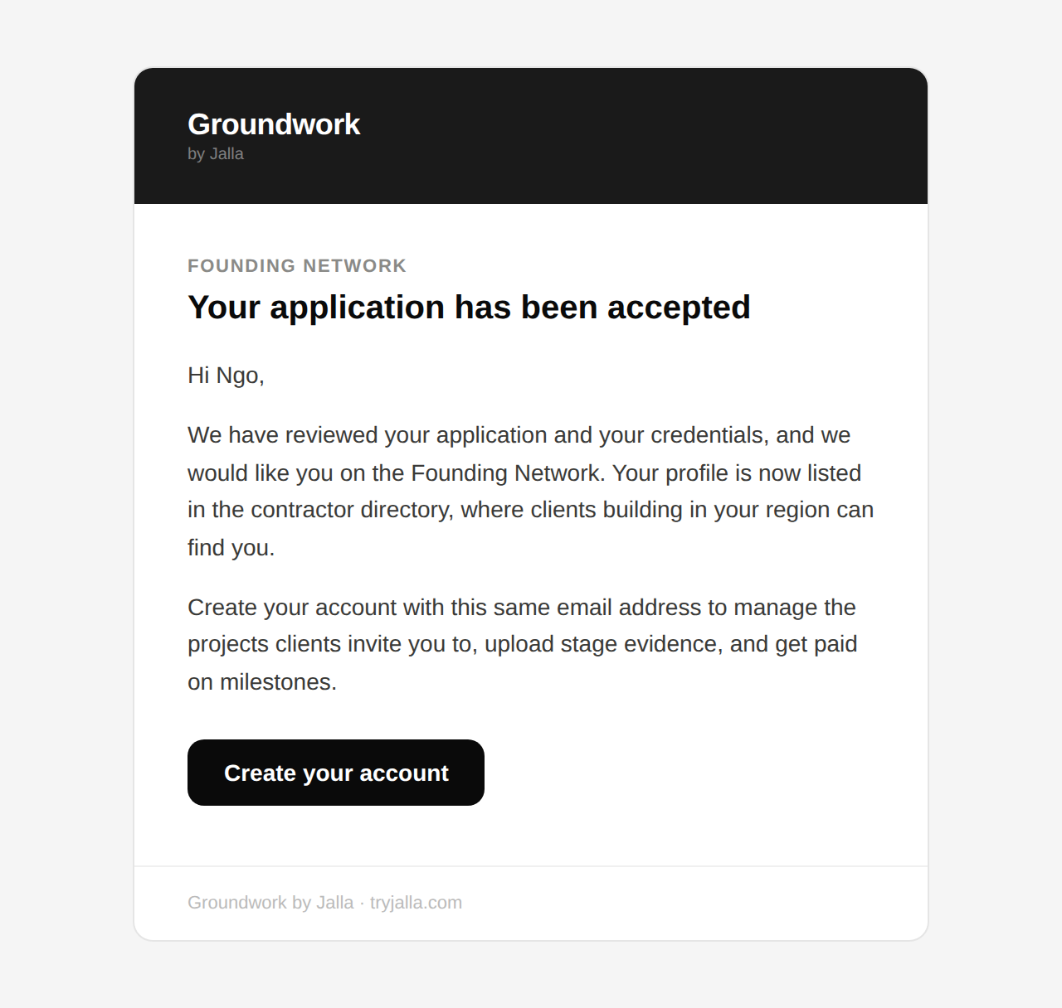

Français — Vous êtes accepté(e) dans le Réseau fondateur Groundwork
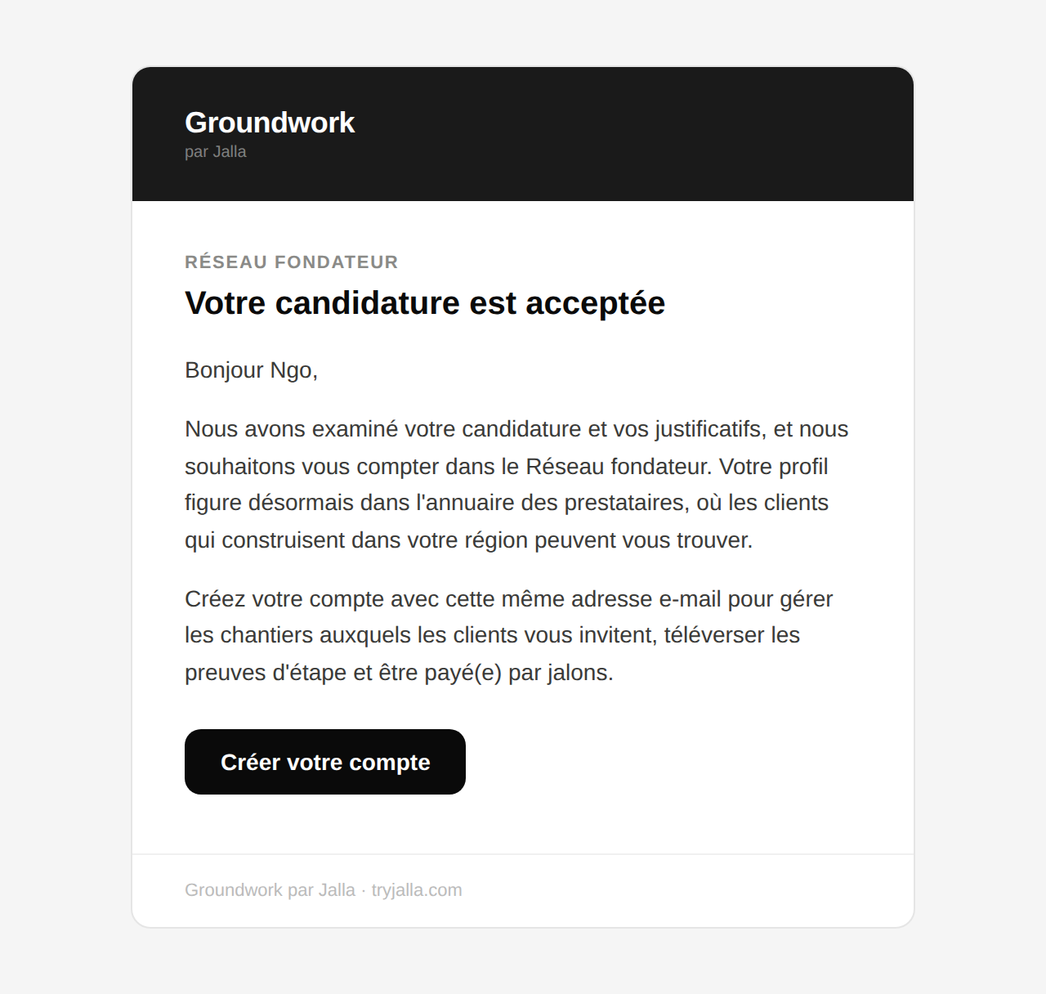

Not accepted — NOT ARRIVING
When | Sent when an admin presses Reject.
Goes to | The applicant
Status | Never arrives, same cause. Carries no reason for the decision — a deliberate choice, argued in the template’s own header.
In the code | api/send-application-decision.ts

English — Your Groundwork Founding Network application
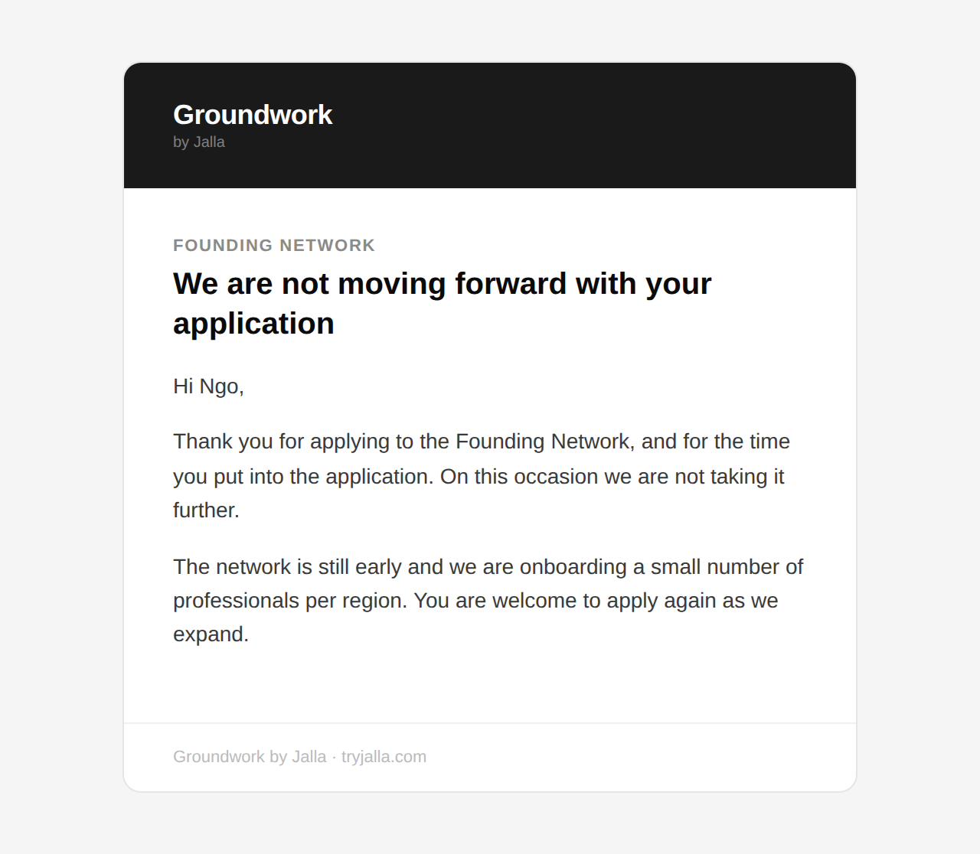

Français — Votre candidature au Réseau fondateur Groundwork
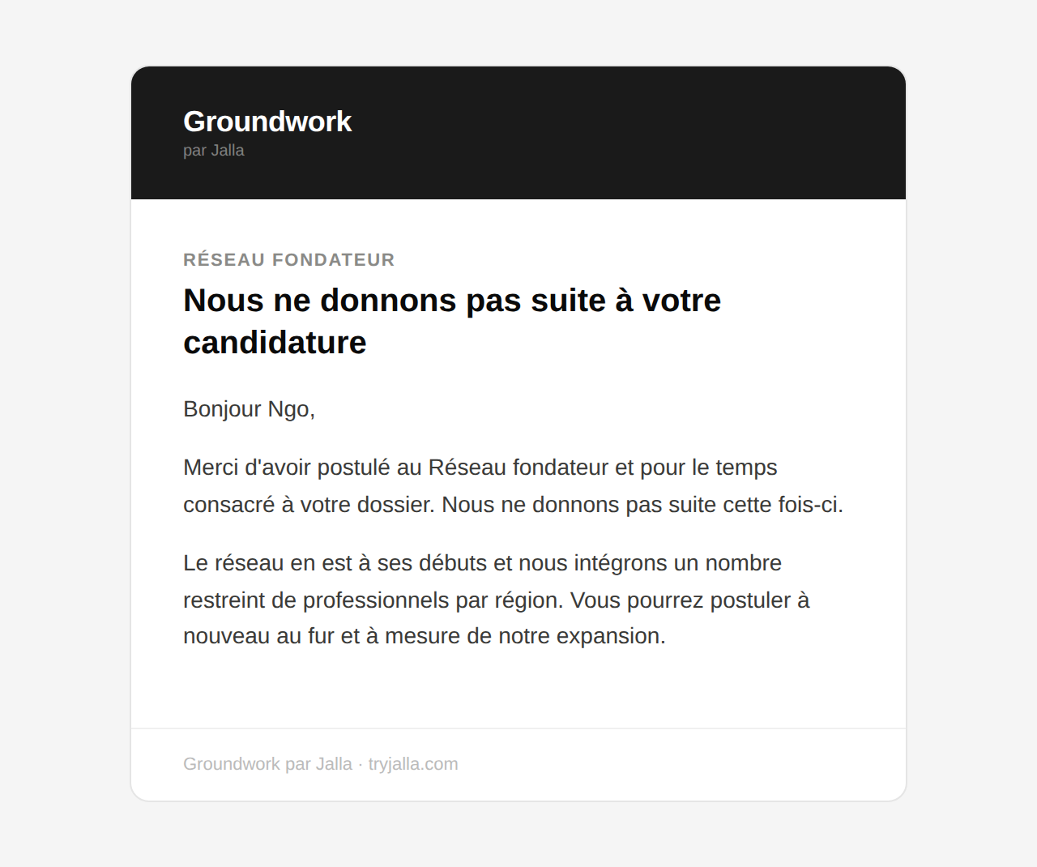

Invited to a project — SENDS
When | Sent when a homeowner invites a contractor onto one of their projects.
Goes to | The invited contractor, who has no account yet
Status | Language is guessed from the project’s build country, since the recipient has no saved preference yet.
In the code | api/send-invite.ts

English — Marie Ateba invited you to a Groundwork project
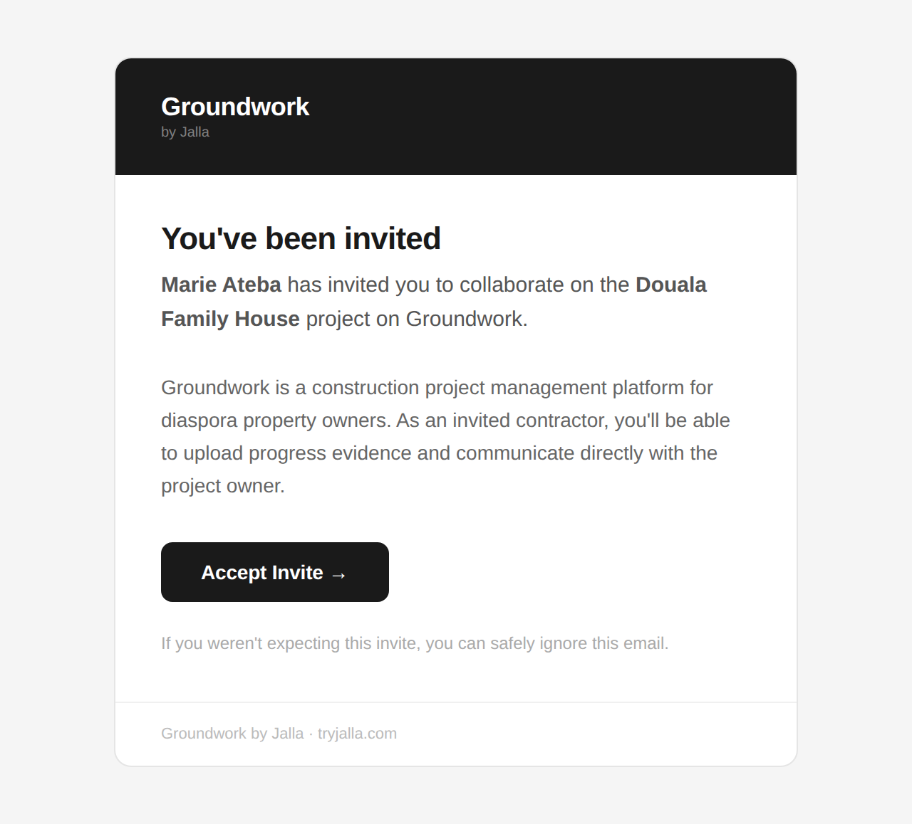

Français — Marie Ateba vous a invité sur un chantier Groundwork
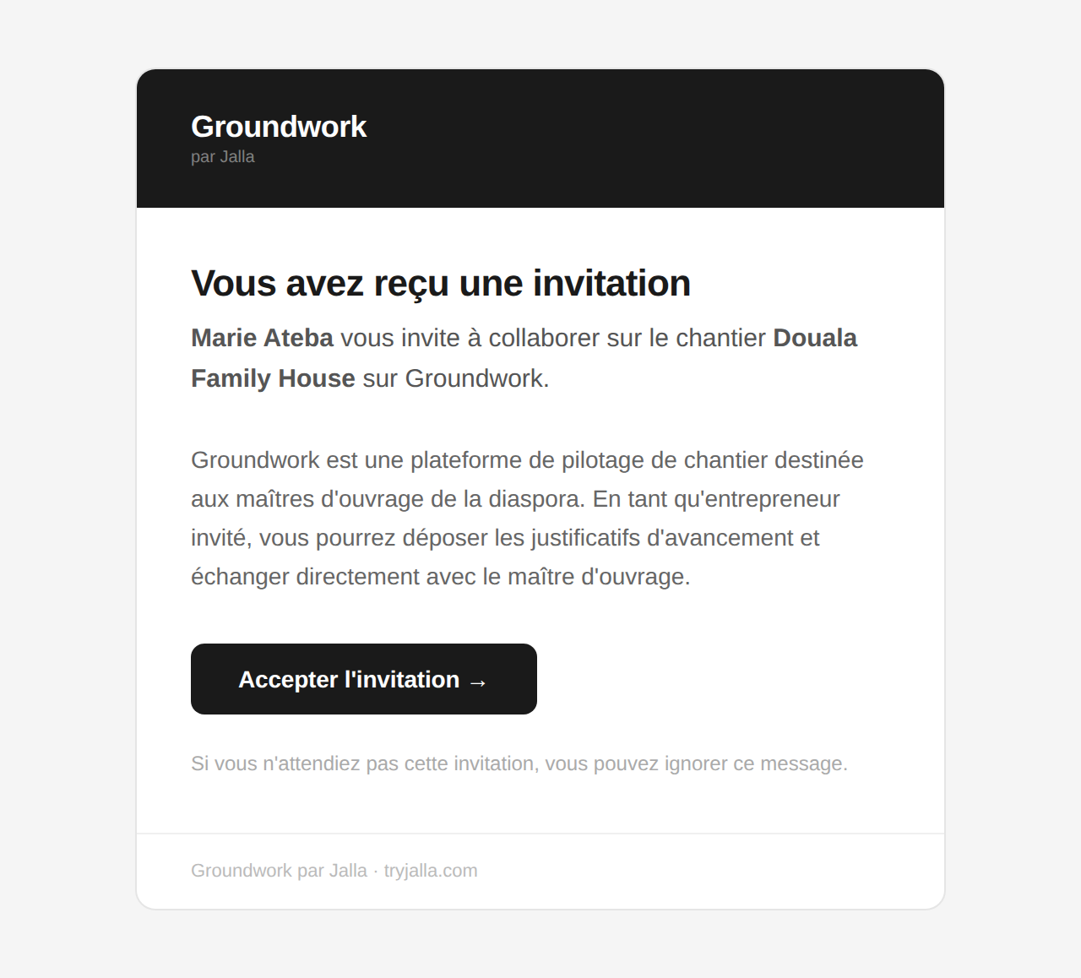

To homeowners
The people paying for a build and watching it from abroad. · 2 emails

Stage approved — NOT ARRIVING
When | Sent when Jalla verifies a construction stage and releases the next one.
Goes to | The homeowner
Status | Has not reached anyone who signed up recently. A database change stopped recording addresses, so the code finds none and returns without sending.
In the code | src/lib/supabase/approvals.ts

English — Stage Approved: Foundation
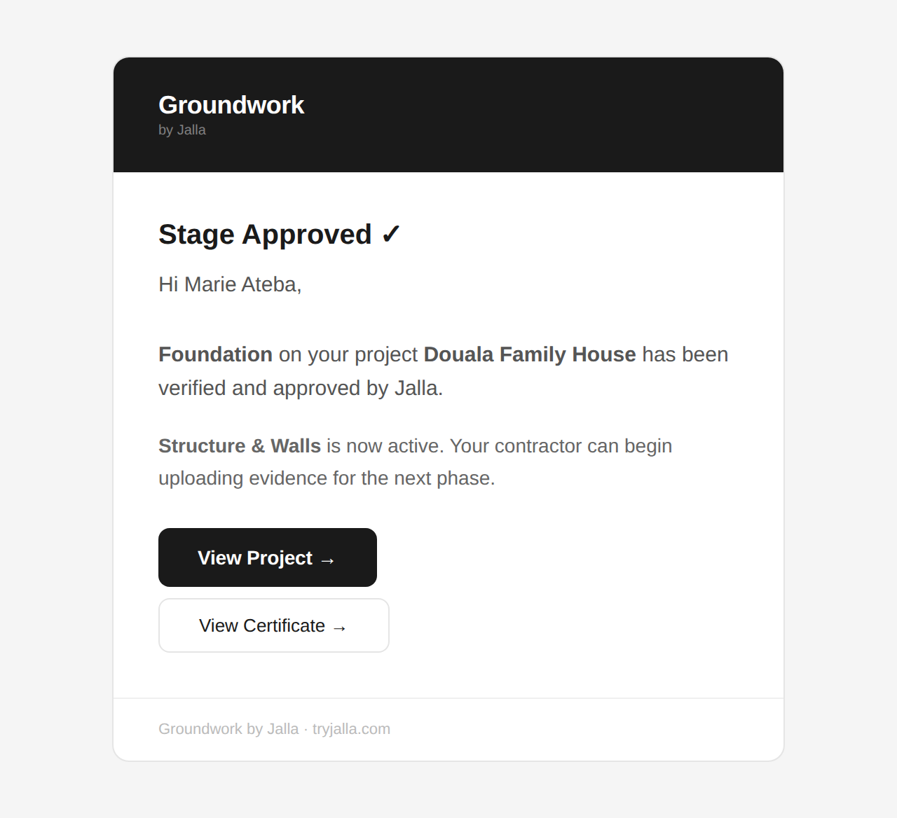

Français — Étape validée : Fondations
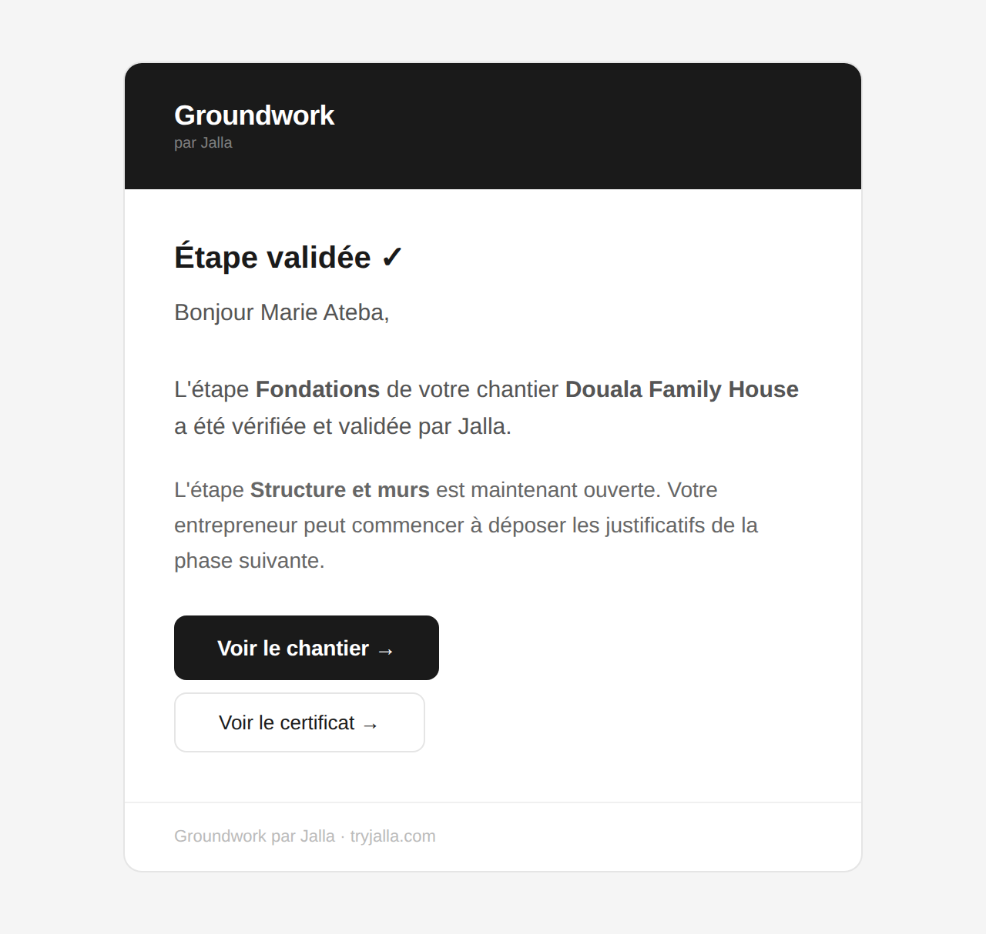

Rework requested — NOT ARRIVING
When | Sent when Jalla rejects a stage and asks for corrections.
Goes to | The homeowner
Status | Same cause as the one above.
In the code | src/lib/supabase/approvals.ts

English — Rework Requested: Foundation
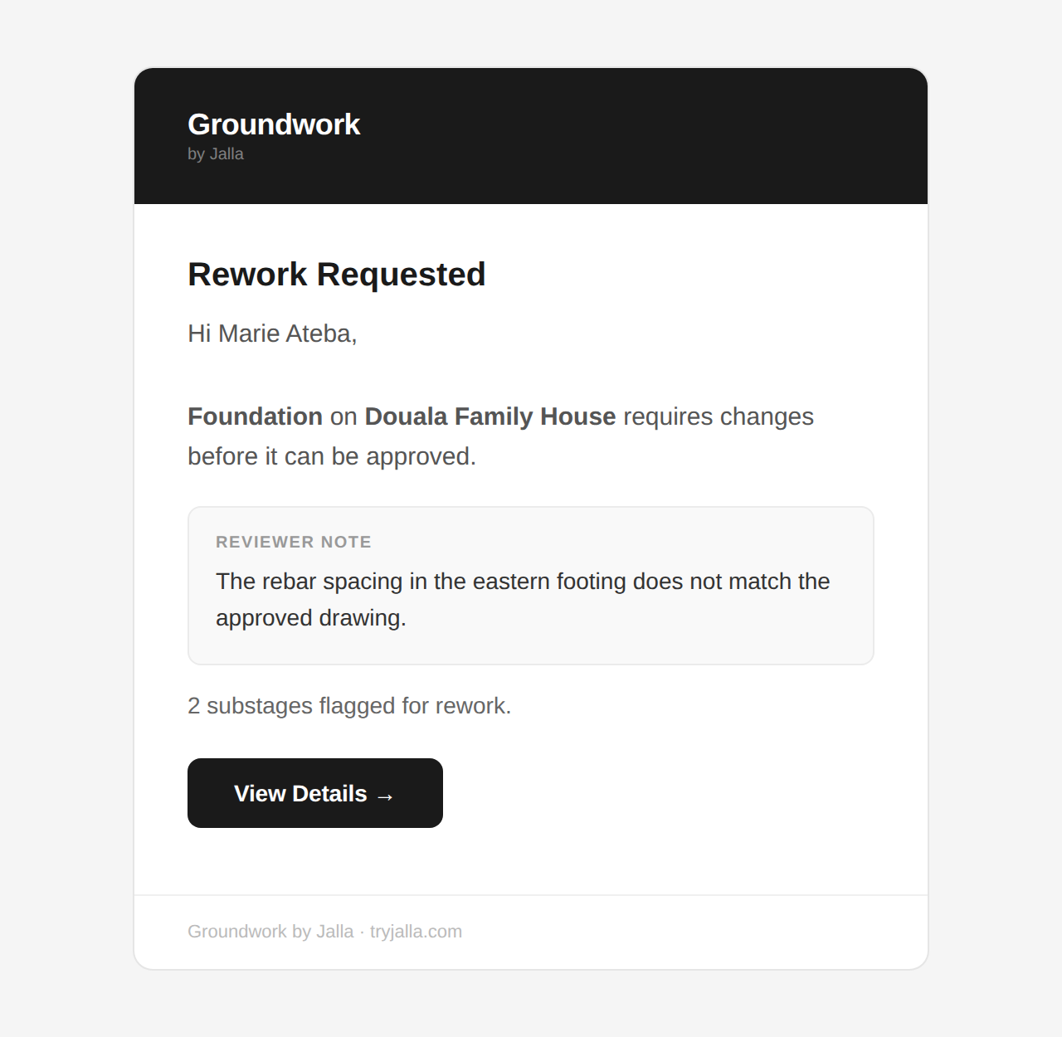

Français — Reprise demandée : Fondations
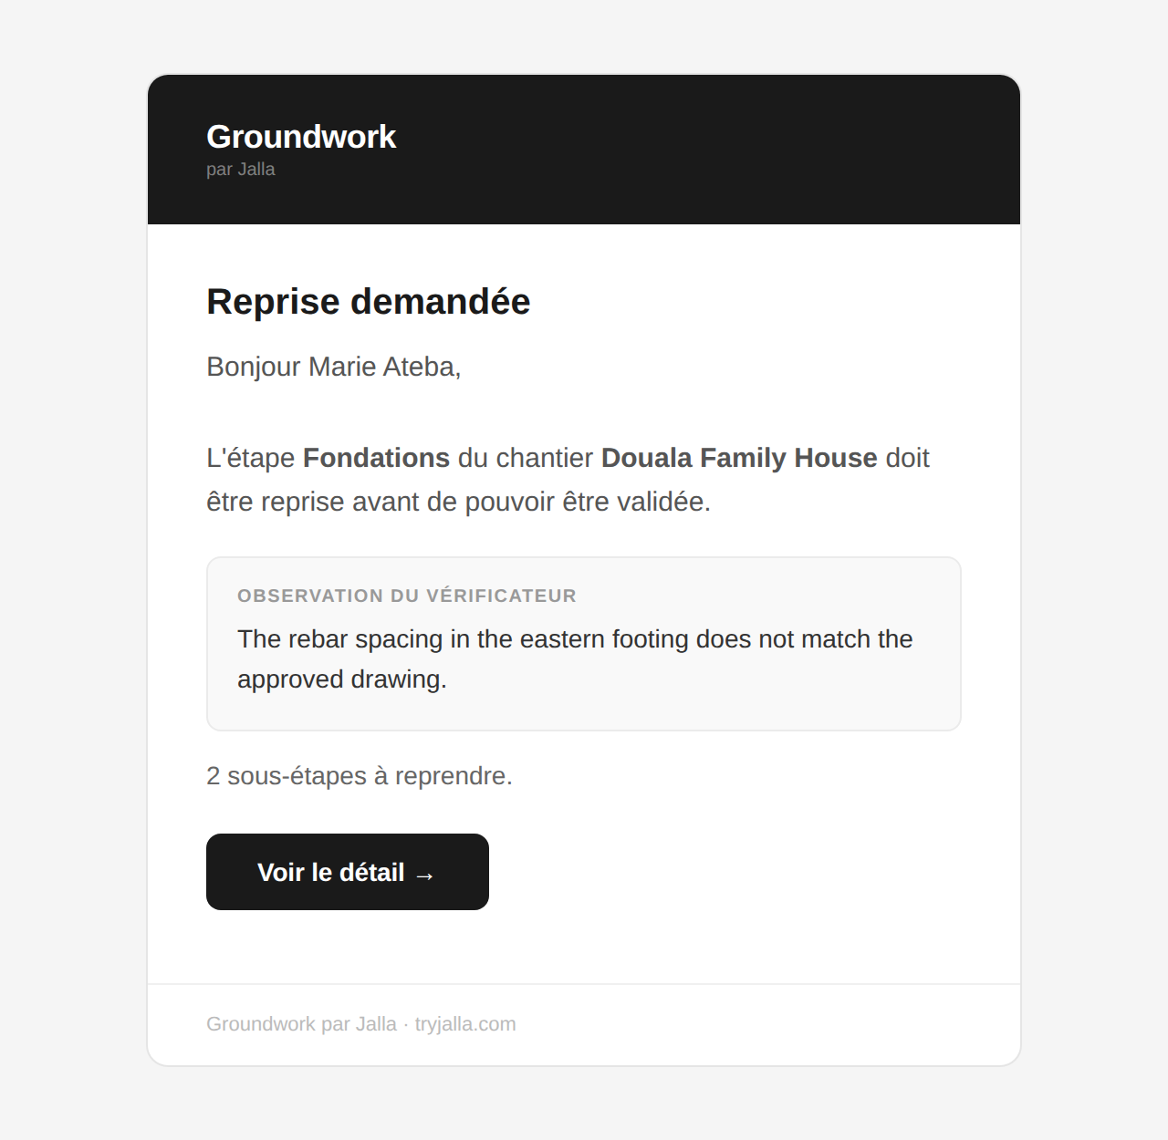

To the Jalla team
Operational alerts. Never seen by a customer. · 1 email

New contractor application — NOT ARRIVING
When | Sent alongside the applicant’s copy, every time the form is submitted.
Goes to | TEAM_INBOX — currently contact@tryjalla.com
Status | English only, on purpose: it goes to the team, not to an applicant. It stopped arriving for the same reason as the applicant’s copy — a coupling now removed, so this one survives even if the other fails.
In the code | api/contractor-application-notify.ts

English — New contractor application — Ngo Bala Etienne
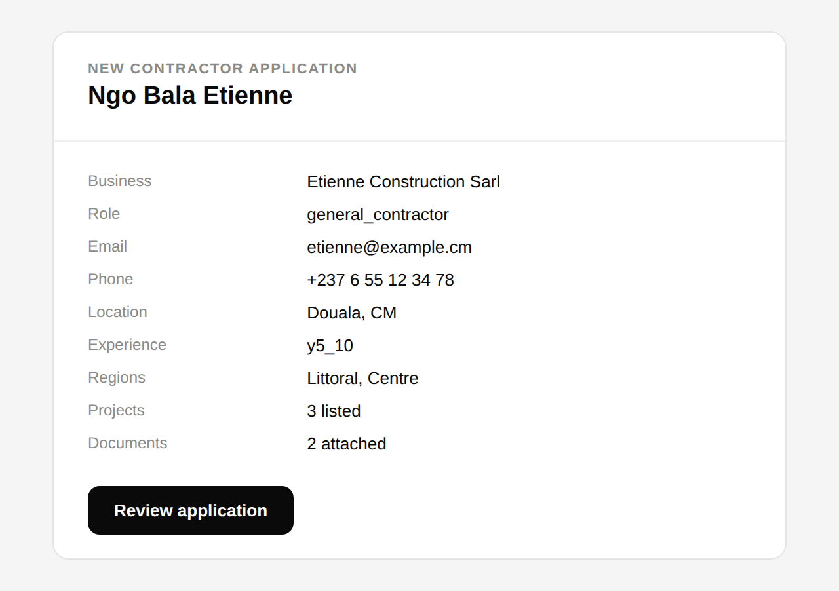

Sent to nobody
Built, deployed, and unreachable. · 1 email

Waitlist welcome — DEAD CODE
When | Nothing triggers it. The page that called it was deleted with the rest of the community feature.
Goes to | Nobody
Status | Fully built and still deployed, so it can be reached by anyone who knows the address. Recommend deleting it.
In the code | api/waitlist-welcome.ts

English — You're on the Groundwork waitlist
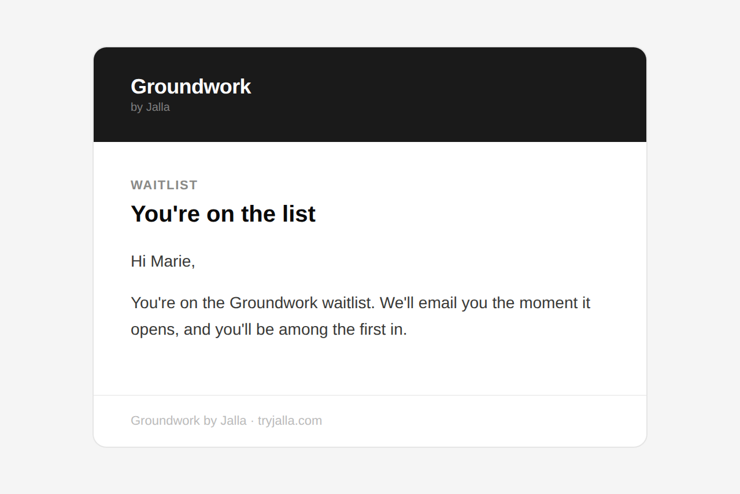

Français — Vous êtes sur la liste d'attente Groundwork
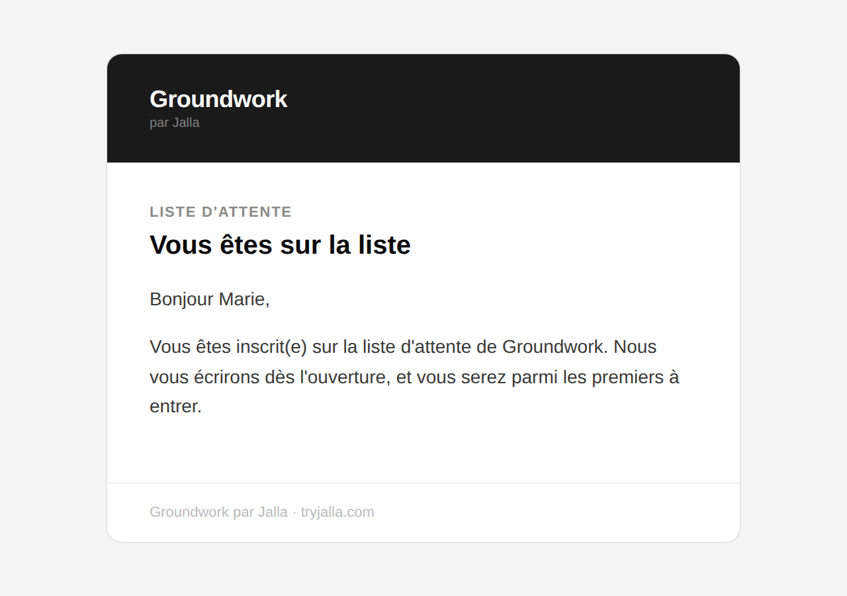

Not ours to show
These are real and they send today, but the wording lives outside our codebase. · 5 emails

Confirm your email address
When | Sent by Supabase the moment someone creates an account. This is the “activation” email.
Goes to | Every new signup
Review it at | Supabase → Authentication → Email Templates → Confirm signup

Confirmation, sent again
When | Sent when someone presses “Resend” on the check-your-email screen.
Goes to | A signup who did not get the first one
Review it at | Supabase → Authentication → Email Templates → Confirm signup

Reset your password
When | Sent from the forgot-password page, and from Settings.
Goes to | Anyone who asks for a reset
Review it at | Supabase → Authentication → Email Templates → Reset password
Note | The two places that send this point the recipient at different pages afterwards. Worth making consistent.

Set up your account
When | Sent after a guest checkout completes, so the payer can claim the account.
Goes to | Someone who paid before creating an account
Review it at | Supabase → Authentication → Email Templates → Invite user

New contractor applied
When | Sent by a Go High Level automation when an application reaches the CRM.
Goes to | Whoever the GHL workflow notifies
Review it at | Go High Level → Automation → Workflows
Note | Probably duplicates the team alert above, so the team may be getting two notifications per application.

Reproduced directly from the live templates, so what you see is what the recipient gets. Sample names, projects and addresses are invented; subject lines, wording, layout and both translations are exactly as sent.

